# Introduction to the Labour Force Survey and Annual Population Survey Workshop

# Instructions for accessing data

The workshop involves a practical session where we will explore the following two datasets.

[Quarterly Labour Force Survey, October - December, 2020](https://beta.ukdataservice.ac.uk/datacatalogue/studies/study?id=8777)

[Labour Force Survey Two-Quarter Longitudinal Dataset, July - December, 2020](https://beta.ukdataservice.ac.uk/datacatalogue/studies/study?id=8778)

To access these datasets, you need to be registered with the UK Data Service. You then add the dataset to your account and set up a project to register the use of the data. This document outlines the steps to take.

## Register with the UK Data Service

If you are not already registered, visit this [website page for details of how to register.](https://www.ukdataservice.ac.uk/get-data/how-to-access/registration/uk-he-fe-users.aspx) There are different instructions depending on your circumstance, use the tabs to select the instructions for you.

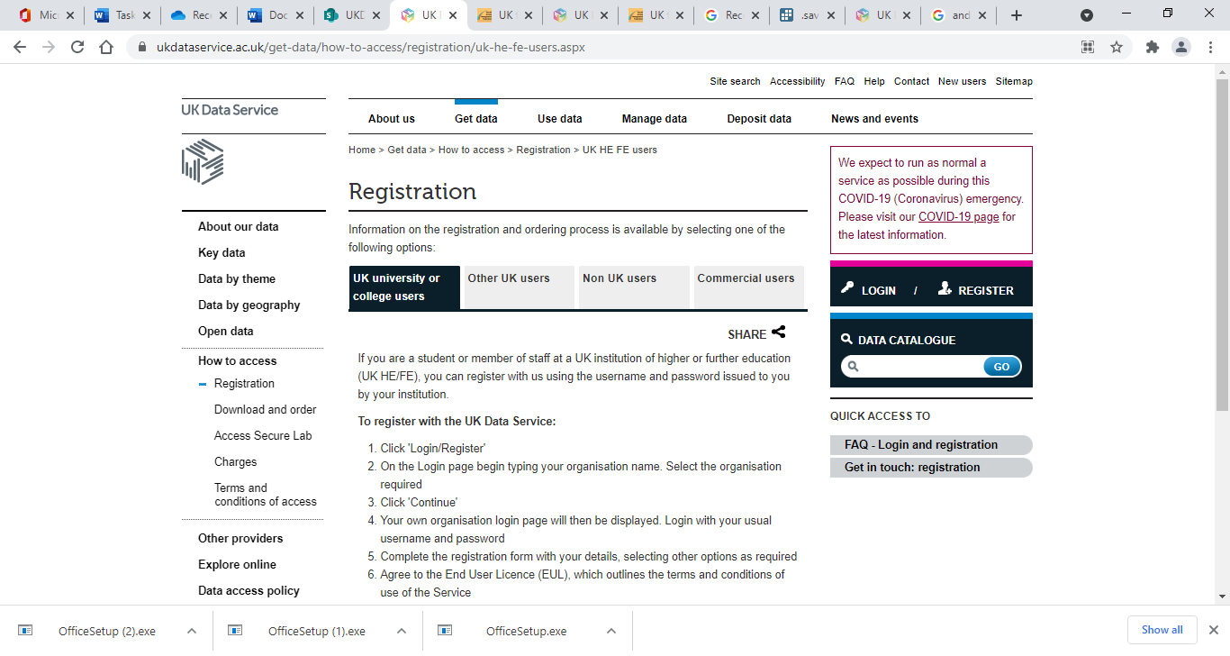

## Find data in the catalogue

Once you are registered, click on the link to go to the relevant catalogue page:

[Quarterly Labour Force Survey, October - December, 2020](https://beta.ukdataservice.ac.uk/datacatalogue/studies/study?id=8777)

On the catalogue page, click on ‘Access data’ on the right of the screen (see picture below).

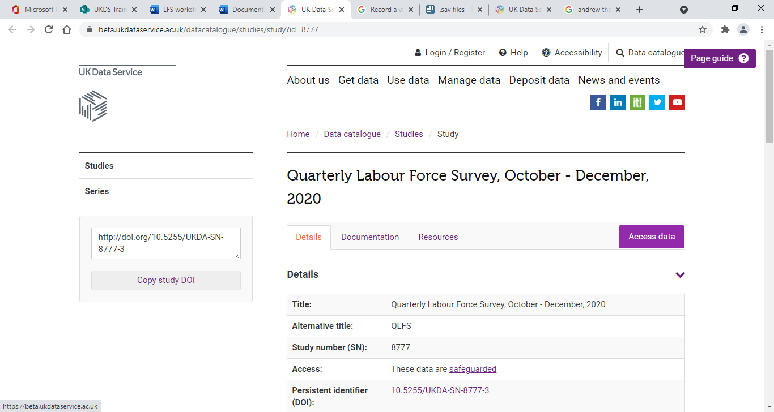

## Access Data

You need to be logged in before you can access the data. On the Access data page, select login if you are not already logged in. Follow the steps on the log-in page.

Once logged in you will have the option to add to your account.

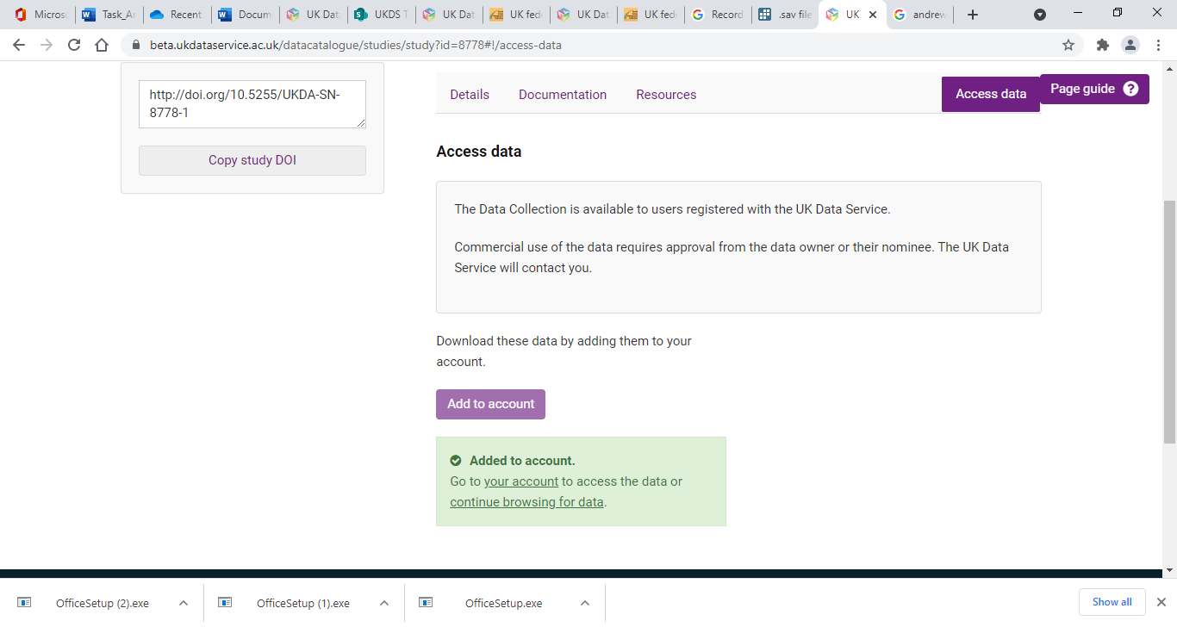

Now visit the catalogue page for the other dataset and add this to your account: [Labour Force Survey Two-Quarter Longitudinal Dataset, July - December, 2020](https://beta.ukdataservice.ac.uk/datacatalogue/studies/study?id=8778)

Once you have added the relevant datasets, go to your account by clicking the ‘your account’ link that appears once you have added the data (You can also click on My account at the top).



## View your account

Under Data in your account area, you should now have the two data sets Awaiting assignment to projects. Select both using the tick box. Select Add to project.

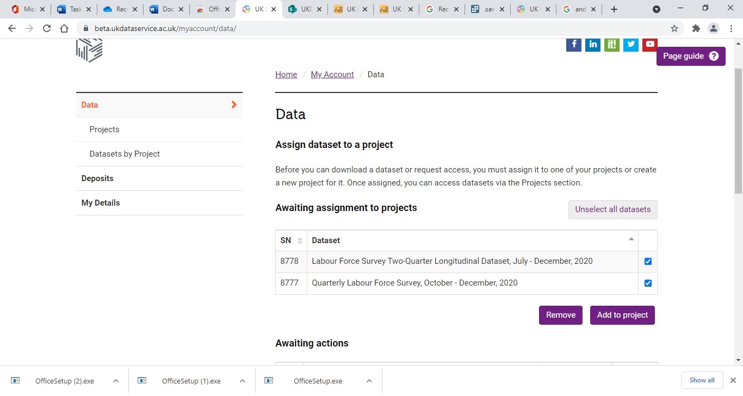

You create a new project or add to an existing project if relevant. For example, you can create a project called LFS workshop with type as non-commercial use. Add a few sentences to describe that you are downloading the data as part of a training course. You can add the data to the project.

With both datasets added to the project, select both using the tick box and select ‘Download selected’. When asked to select the file type, select the SPSS verion (or Stata if preferred).

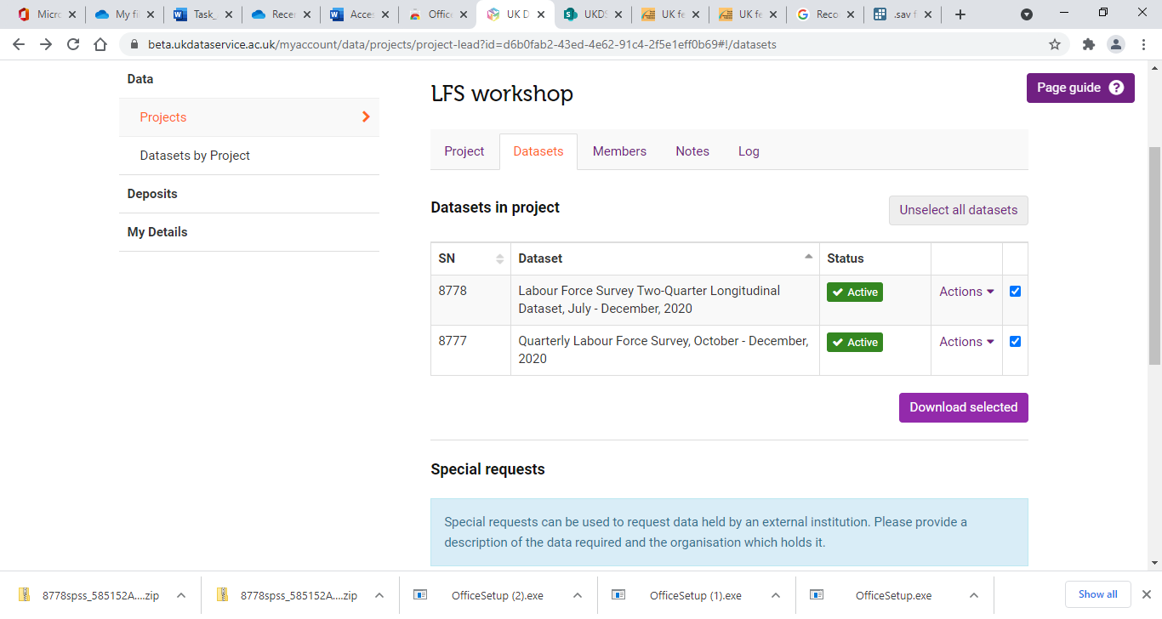

You will now have downloaded two zip files. To use in the workshop, you will need to extract and save to a location accessible on the day.